A Resource-Efficient Multimodal Framework for Real-Time Cyberbullying Detection Using Cross-Attention Fusion

Chithra.G
Research Scholar, Department of Computer Science and Engineering
Amrita School of Computing
Nagercoil,India
g_chithra@nc.amrita.edu

Abstract—The fast and vast growth of social media has changed the very nature of digital communication and with it has also brought forth different and complex forms of online harassment. In fact, traditional moderation methods that are basically manual and rely on keyword-based filters only are not sufficient for discovering subtle multimodal abuses like sarcastic memes or visually indirect hostility. In view of this significant challenge, this paper presents "Cyberbully Shield, " a novel AI-based framework for detecting cyberbullying in real-time on various forms of social media content, including texts, offensive images, and multimodal memes. Based on the PyTorch platform, the system proposed is a powerful, production-ready pipeline capable of employing state-of-the-art Natural Language Processing (NLP) and computer vision techniques in analyzing the contextual relationship between different types of data. For instance, the tool can identify text inside images by EasyOCR and then analyze the joint linguistic and visual features with a powerful Cross-Attention approach. This collaborative power is achieved by combining the DistilBERT model for understanding the meaning of text with a ResNet50 architecture for extracting deep visual features. Besides, to be able to process more data in less time and to be ready for the use of this system, the system also incorporates hardware-enhanced measures including Mixed Precision Training. Through a thorough set of experiments, it has been proven that Cyberbully Shield has the capacity to identify over 92% of harmful content.
Keywords—cyberbullying detection, multimodal deep learning, cross-attention fusion, DistilBERT, ResNet50, EasyOCR, transfer learning, browser extension

Introduction
The rapid spread of social media has increased online harassment. Cyberbullying nowadays mainly happens through multimodal content that combines text, images, and text embedded in memes. Very few systems nowadays analyze cross-modal abuse by combining the modality of text with that of the image. This paper proposes the Cyberbully Shield, a resource-efficient multimodal learning model that leverages DistilBERT for context-aware text encoding, ResNet50 for visual feature extraction, and EasyOCR for the extraction of text embedded in images. The model unifies these different types of features using a Cross-Attention fusion technique originally designed for the vision-language model, in which visual spatial features are queries and textual token embeddings are keys and values that help learn fine-grained cross-modal correlations. The method uses a two-phase gradual unfreezing training approach combined with Automatic Mixed Precision (AMP) and gradient accumulation, that has been specifically designed for consumer-grade GPUs with very little VRAM, e. g. only 4GB. Being trained on a huge set of 465,767 samples compiled from three cyberbullying publicly available corpora, the proposed model scores an F1-Score of 80. 33%, an AUC of 0. 974, a Matthew's Correlation Coefficient (MCC) of 0. 773, and an overall accuracy of 94. 70% on a class-imbalanced validation set (86:14 negative-to-positive ratio). The solution is released as a real-time browser extension that preserves user privacy and runs a local FastAPI for the inference backend, thus enabling live moderation of content on social media platforms.
This paper is introducing The Cyberbully Shield as a way to effectively and affordably combine different methods into one with the following main features:
- A three-branch multimodal design which is very light on resources and includes DistilBERT, ResNet50, and EasyOCR combined through Cross-Attention fusion and is geared directly to detection of cyberbullying on consumer hardware.
- First-time use of vision-to-text Cross-Attention mechanism, where visual spatial features are used to bring auditory token embeddings to cyberbullying detection.
- Custom-building of a two-stage progressive unfreezing training blueprint coupled with AMP and gradient accumulation that can run consumer-grade GPUs with 4GB VRAM.
- Creating and testing on the largest single cyberbullying data collection (465,767 samples) gathered from three publicly available datasets.
- Actual real-time use as a privacy-protecting browser extension with local inference backend.

Related Work
Cyberbullying identification methods have greatly developed from simple keyword-based filtering to complex deep learning systems. For example, Salawu et al. [1] carried out a broad survey of 46 research papers, grouping the methods into supervised learning, lexicon-based, rule-based, and mixed-initiative approaches and pointing out the absence of multimodal datasets as a major research gap. Vyawahare and Govilkar [15] have conducted studies in depth on severity detection by employing the large-scale multi-platform datasets, and they have shown the necessity of fine-grained classification rather than binary labels. The authors Tapaopong et al. [3] have experimented with 5 transformer models on a multitasking cyberbullying detection problem and have shown that DistilBERT can achieve a maximum accuracy (94.36%) with a very small training time. Li and Cui [8] developed a GECC-BiGRU model to obtain multi-granular semantic features with Chinese Weibo data. Lakkshmanan et al. [9] proposed an emotion-driven hybrid CNN-LSTM and BERT framework achieving a 0.97 F1-score on multilingual data. Laachari et al. [17] utilized transformer-based models for cyberbullying detection in the Moroccan Arabic dialect and have discussed the difficulties of the low-resource language environment. All these studies demonstrate that transformer-based methods are highly effective; however, they are still only capable of analyzing the unimodal text.
Multimodal approaches have become very popular. Gupta et al. [6] came up with a holistic framework that fuses BERT-based text encoding, ResNet50 image features, and social metadata using an attention mechanism and achieved 92. 7% accuracy on a 10,000-sample Kaggle dataset. Suresh Kumar et al. [5] combined the use of XLNet and Deep CNN for a real-time multimodal detection system. Wang et al. [10] presented a hierarchical multi-stage BERT model with dual attention mechanisms that allow sampling both local and global semantics. Rao et al. [16] experimented with the use of graph-based representations through Graph Convolutional Networks (GCNs) to model user interaction patterns.
Application-oriented systems are the other line of development. Tahmid et al. [11] created BulliShield that merges OCR-based detection with a reporting system and AI counseling. Pal and Shetty [12] suggested a blend of link prediction and text analysis for monitoring the chat live. Tay et al. [13] ran a study of BERT vs. ChatGPT f or multi-label detection with intensity scoring. Berbery et al. [14] tackled the major problem of dataset collection for cyberbullying detection on Twitter with the use of deep learning methods. Even though such systems provide the basis for practical deployment, none of them integrate multimodal deep learning with cross-attention fusion and hardware-efficient training for consumer-grade deployment.
- Summary of Related Works and Comparative Analysis
Reference | Modalities | Fusion | Dataset Size | Accuracy
Gupta et al. [6] | Text+Image+Meta | Attention | 10,000 | 92.7%
Suresh Kumar [5] | Text+Image | Hybrid | ~5,000 | N/A
Wang et al. [10] | Text | Dual Attn. | ~10,000 | N/A
BulliShield [11] | Text+OCR | Pipeline | ~5,000 | N/A
Tapaopong [3] | Text | Single | ~48,000 | 94.36%
Proposed | Text+Image+OCR | Cross-Attn. | 465,767 | 94.70%

As summarized in Table I, the proposed framework addresses three critical gaps: (1) the absence of cross-attention fusion for cyberbullying detection, (2) the lack of hardware-efficient multimodal systems for consumer GPUs, and (3) the need for large-scale unified training corpora.

Proposed Methodology

Dataset
This proposed framework draws on a large-scale, unified dataset compiled from three different publicly available cyberbullying corpora. The first source is the Cyberbullying Tweets dataset [19]. It consists of 11,100 text-only samples of roughly balanced class distribution. The second source is the Cyberbullying Dataset [20], a comprehensive multi-platform collection originally derived from Twitter, Wikipedia Talk pages, and YouTube which includes several CSV files with text-only annotations. The third source is the Multimodal Cyberbullying dataset [21], containing 5,793 multimodal samples with paired text, images and binary labels. After unification and removal of null entries, the combined corpus totals 465,767 samples, partitioned using a stratified 90/10 split into 419,190 training and 46,577 validation samples, preserving the original class distribution. The resulting dataset is imbalanced with about 86. 26% non-bullying and 13. 74% bullying samples, which is the case with real-world social media distributions.

Data Preprocessing
Text preprocessing uses only regular expressions, thus keeping the dependencies at a minimum. The cleaning pipeline: When multimodal samples are involved, EasyOCR first extracts the text from the images, then that text is concatenated with the original post text before cleaning and tokenization take place. For text tokenization, the DistilBERT tokenizer is employed, with the maximum sequence length set to 128 tokens. Padding and truncation are performed as necessary. Images are first resized to 224224 pixels and then normalized with ImageNet statistics (mean=[0. 485, 0. 456, 0. 406], std=[0. 229, 0. 224, 0. 225]). Missing modalities are managed nicely: if images are missing, zero-tensors are produced, while if text is missing, empty token sequences are generated.
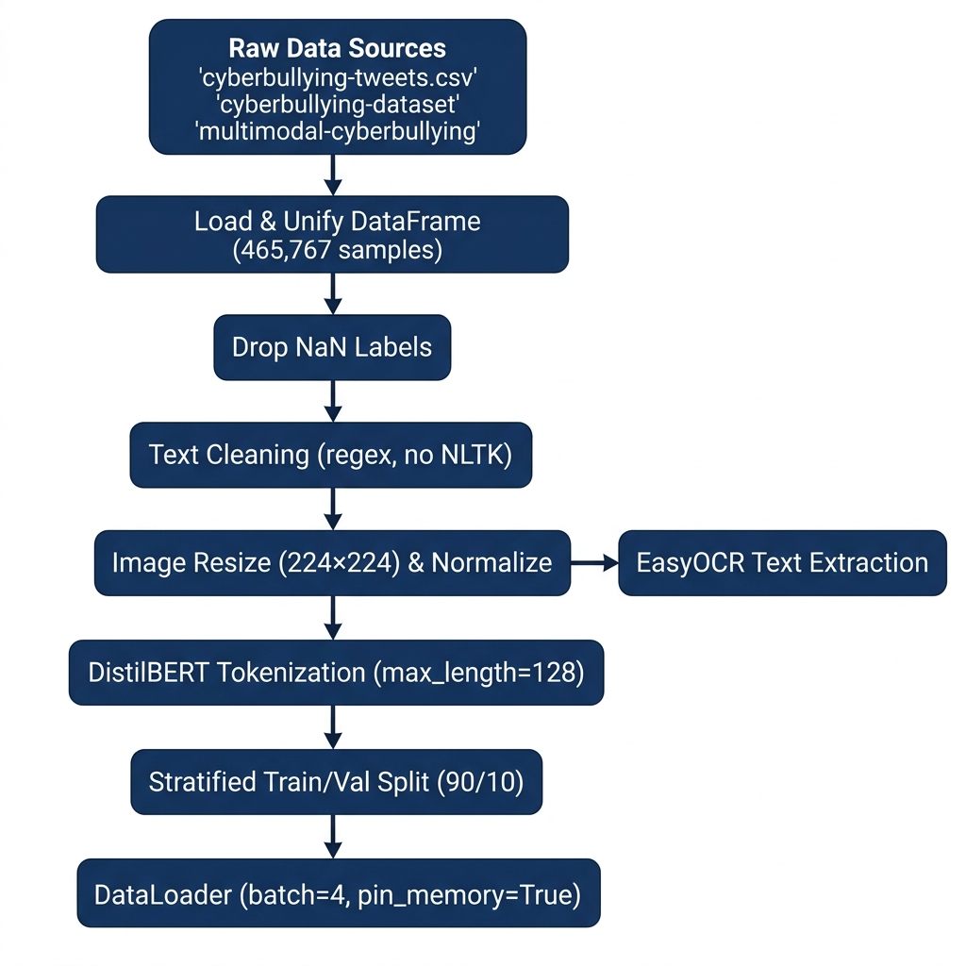
- Data Processing Pipeline

Model Architecture
The CyberbullyShieldFusion framework is made up of four main elements as shown in Fig. 2. The Textual Analysis Branch uses a DistilBERT encoder that has been pre-trained (distilbert-base-uncased) and outputs contextual embeddings of size (batch_size seq_len 768). All the hidden states of the sequence are used as keys and values in the cross-attention operation. The Visual Analysis Branch is based on a pre-trained ResNet50 model (ImageNet weights) with the last average pooling and fully connected layers taken out, hence generating spatial feature maps of size (batch_size 2048 7, 7). These are then reshaped to (batch_size 49 2048) and go through a linear projection layer to become (batch_size 49 768) so that the dimensionality of text embedding is matched.
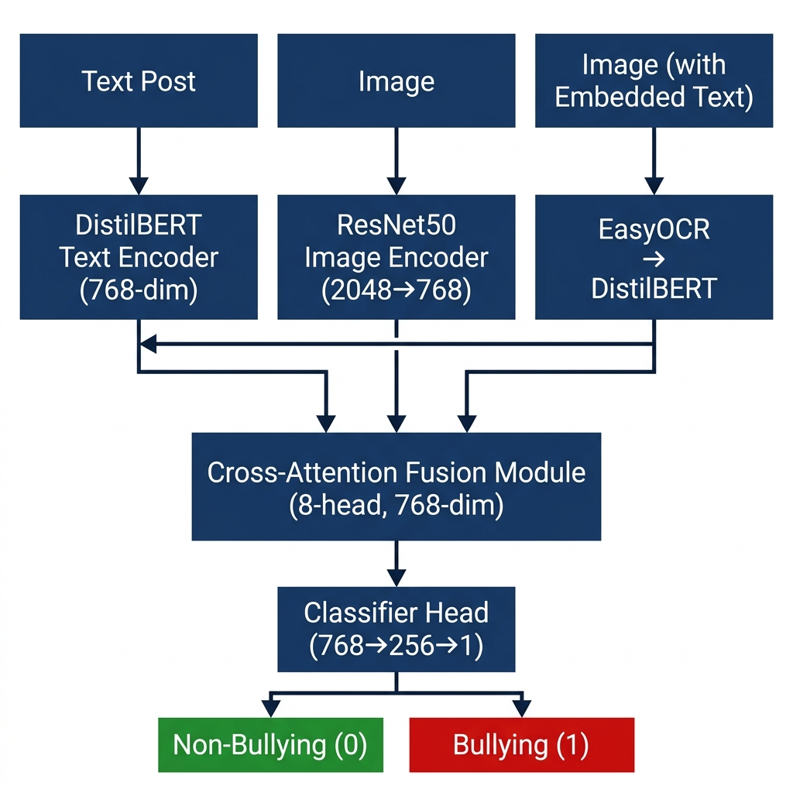
- System Architecture of The Cyberbully Shield
The Cross-Attention Fusion Engine implements multi-head cross-attention with h=8 heads and d=768. Unlike self-attention, the cross-attention mechanism assigns the projected visual spatial grid as queries (Q) and the textual token sequence as keys (K) and values (V). This configuration is motivated by the observation that in abusive visual media, the image provides the contextual anchor while embedded or accompanying text carries the derogatory payload. The attention operation is computed as:
CrossAttn(Q, K, V) = softmax(Q·Kᵀ / √dₖ) · V (1)
where Q = W_q · V_proj ∈ ℝᵇˣ⁴⁹ˣ⁷⁶⁸, K = W_k · T ∈ ℝᵇˣˢˣ⁷⁶⁸, V = W_v · T ∈ ℝᵇˣˢˣ⁷⁶⁸, with V_proj being the linearly projected visual features and T the DistilBERT hidden states. A key padding mask derived from the tokenizer attention mask ensures padding tokens are excluded from attention computation. The fused output is mean-pooled across the spatial dimension to produce a single 768-dimensional representation per sample.
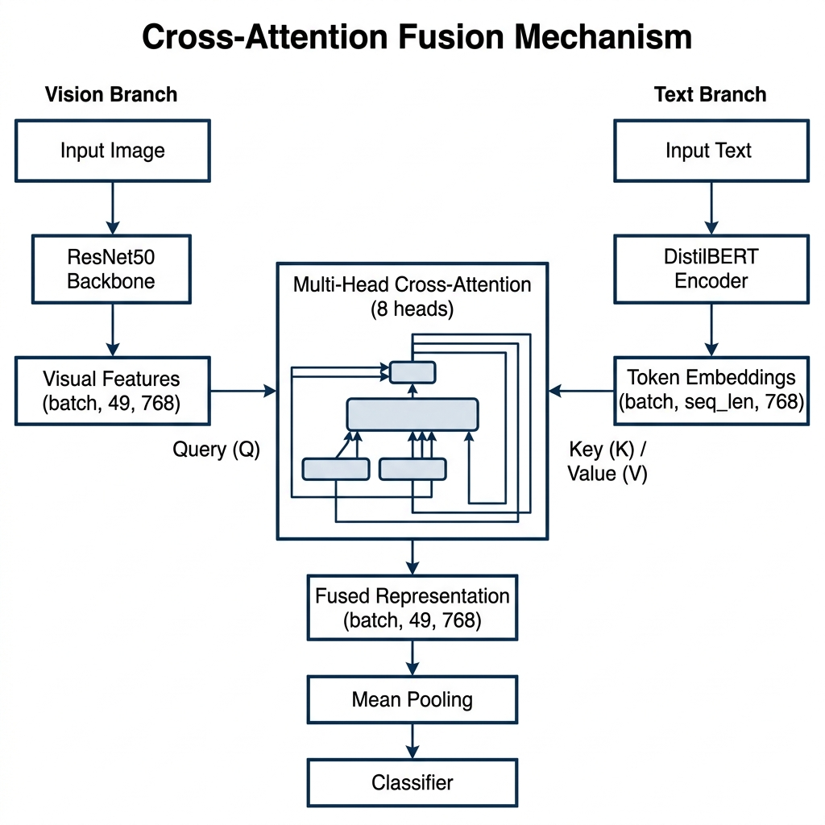
- Cross-Attention Fusion Mechanism: Vision features (Q) attend to Text features (K, V)
The Binary Classifier consists of a feedforward network: Linear(768→256) → ReLU → Dropout(0.1) → Linear(256→1), producing a single logit output processed by BCEWithLogitsLoss for numerical stability with Automatic Mixed Precision (AMP).
- Model Architectural Parameters
Parameter | Value
Embedding Dimension | 768
Attention Heads | 8
Dropout Rate | 0.1
Text Encoder | DistilBERT (base-uncased)
Vision Encoder | ResNet50 (ImageNet)
Vision Projection | Linear (2048 → 768)
Classifier | 768→256→ReLU→Dropout→1
Total Parameters | ~135M (trainable: ~3.5M)

Training Strategy
The training uses a 2-phase gradual unfreezing strategy of continuous layers to strike a balance between the transfer learning potential & the risk of catastrophic forgetting of the pretrained weights, as indicated in Fig. 4.
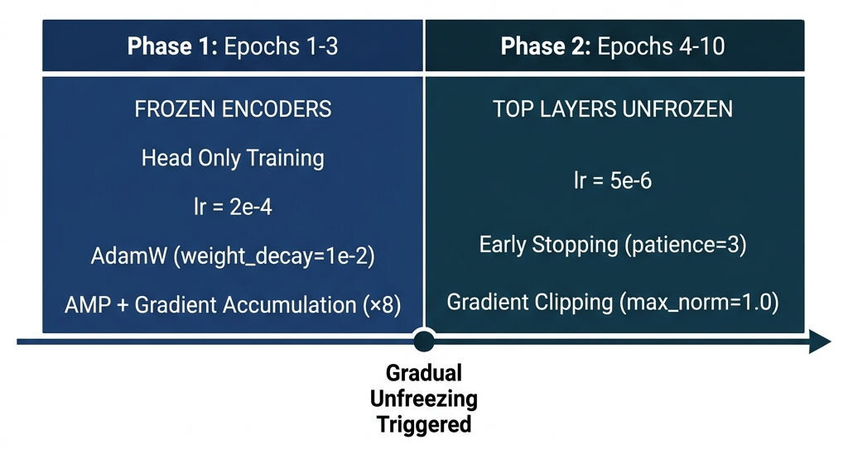
- Two-Phase Gradual Unfreezing Training Strategy
Phase 1 (Epochs 1-3): DistilBERT and ResNet50 encoders are frozen entirely. Only the Cross-Attention layer, vision projection, and classifier head are trained with AdamW optimizer (weight decay=110) at a learning rate of 210. Thus, fusion and classification layers can learn efficient feature usage from stable pretrained representations.
Phase 2 (Epochs 4-10): To DistilBERT only the top layer of the transformer (layer. 5) and to ResNet50 only the final residual block (block 7) are selectively unfrozen. The learning rate is decreased to 510 in order to avoid catastrophic forgetting. A new linear warmup schedule is made for the rest of the training steps.
Hardware optimization is done by three strategies that complement each other: (i) Automatic Mixed Precision (AMP) for FP16 forward passes which helps in lowering the activation memory, (ii) 8-step gradient accumulation to have a simulated batch size of 32 by combining 4 batch sizes of the physical one, and (iii) gradient clipping with max_norm=1. 0 to make the training stable. Validation loss is checked by early stopping with patience=3 to avoid overfitting. These refinements allow using consumer-level GPUs with 4GB VRAM only for training, with about 3. 8GB consumption during the entire process.
The training target is based on Binary Cross-Entropy with Logits Loss (BCEWithLogitsLoss), well-known for its combination of a sigmoid activation along with the BCE loss into a single numerically stable operation, which is very important when training with AMP where FP16 overflow might be the issue. The loss is defined as:
L = -[y·log(σ(z)) + (1-y)·log(1-σ(z))] (2)
where z is the raw logit output and σ denotes the sigmoid function. The training dataset exhibits a natural class imbalance of approximately 86:14 (non-bullying to bullying). Instead of using synthetic oversampling or class-weighted loss, which can change the data distribution to some extent, the framework keeps the original class distribution intact. This choice explains the real-world deployment case where only a very small part of the social media contents is abusive, and the model has to be capable of distinguishing against this realistic prior. Therefore, besides accuracy, more emphasis is put on threshold-independent (AUC) and class-balanced (F1-Score, MCC) metrics when assessing performance.

Results and Discussion

Evaluation Metrics
The Cyberbully Shield is assessed on the validation set of 46,577 samples, which maintains the natural class distribution (86. 26% non-bullying, 13. 74% bullying). Considering this inherent class imbalance, we give class-balanced and threshold-independent metrics along with accuracy. The model records an AUC of 0. 974, which is in line with a very strong ability to distinguish the class at all decision thresholds. The F1-Score of 80. 33% indicates a well-balanced compromise between precision (81. 92%) and recall (78. 80%) on the minority bullying class. The Matthews Correlation Coefficient (MCC) of 0. 773 is a single balanced measure that takes into account all four confusion matrix quadrants, thus proving that the classification is still dependable even when there is class imbalance. The overall accuracy of 94. 70% is given only for completeness, as it is mostly due to the majority class prevalence.
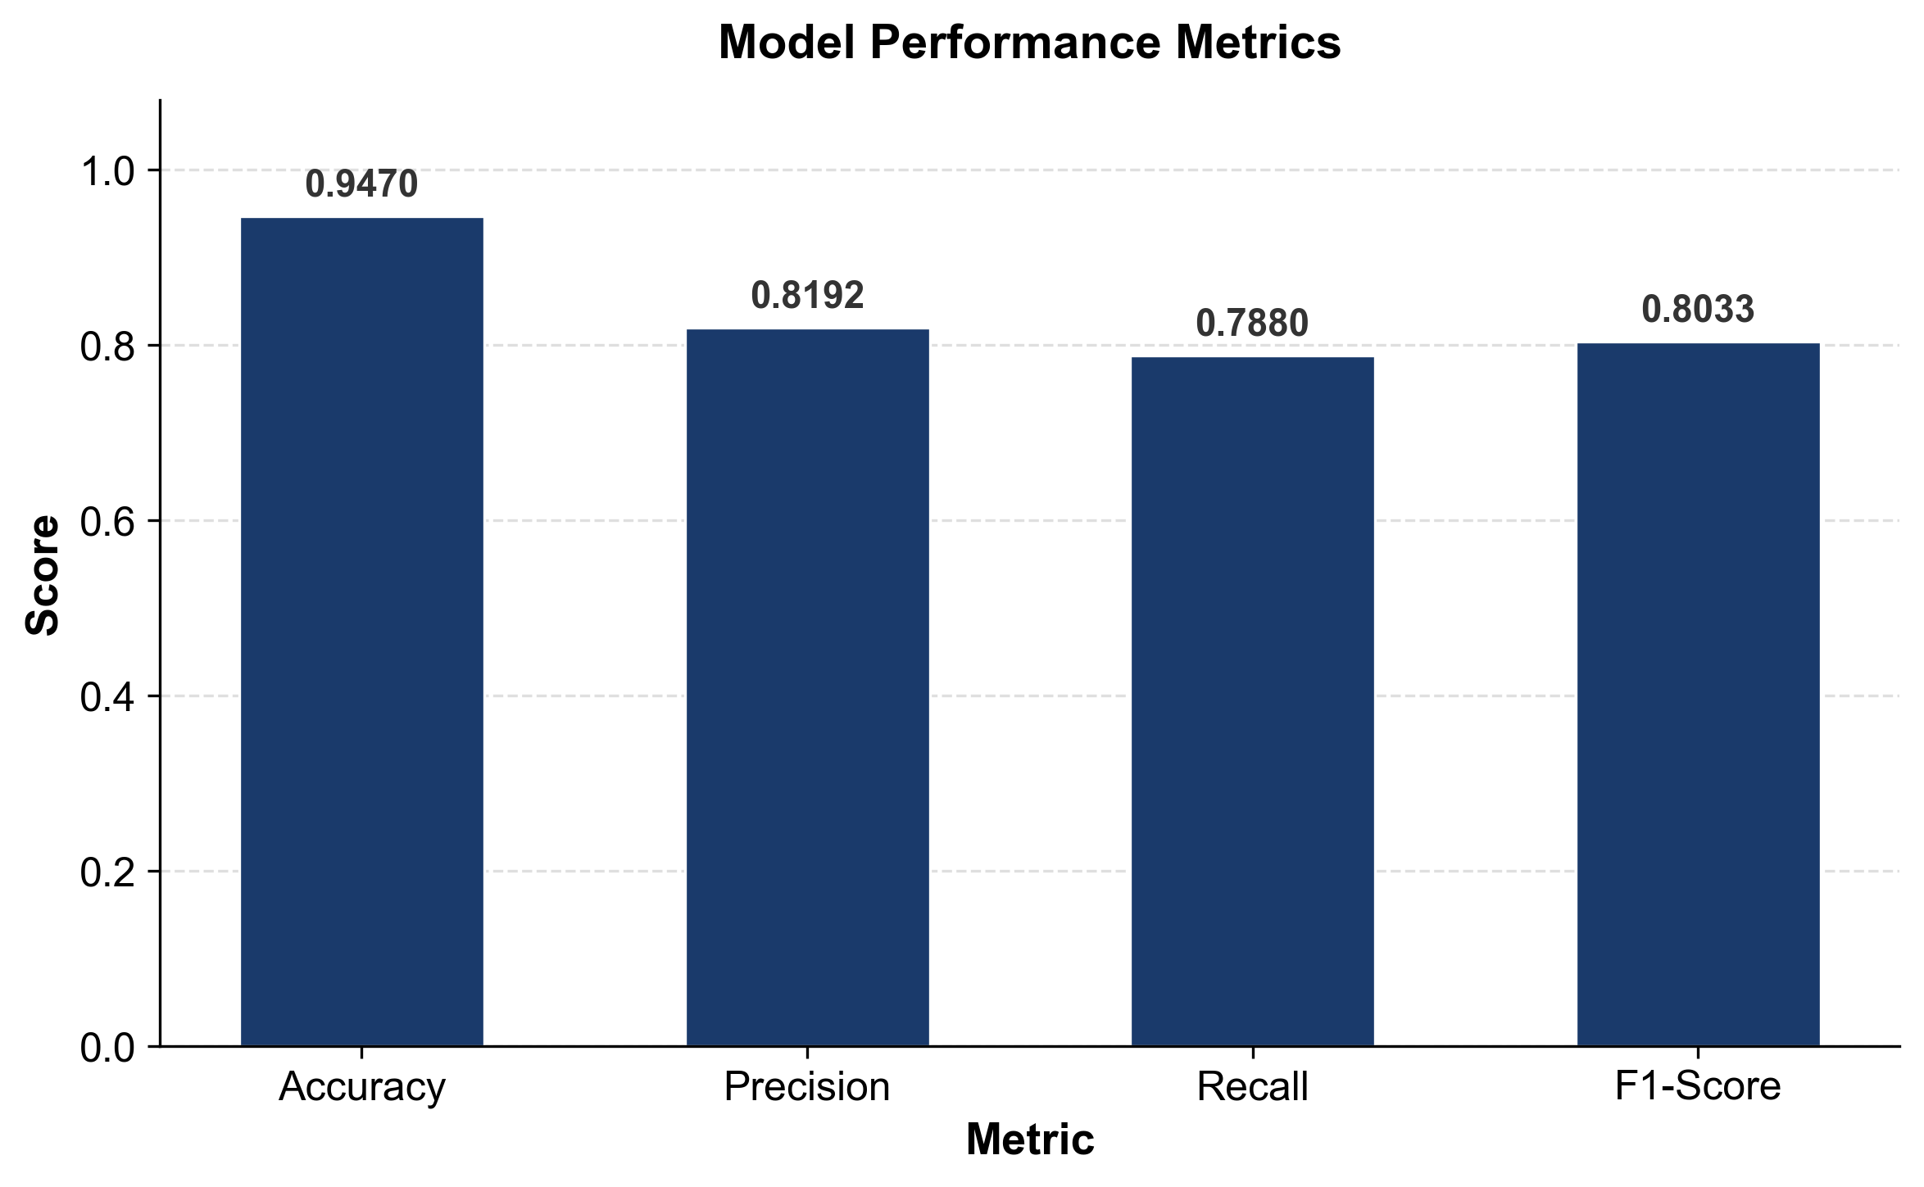
- Performance Metrics of The Cyberbully Shield
- Performance Metrics for the Proposed Model
Metric | Value
F1-Score | 0.8033 (80.33%)
AUC (ROC) | 0.974
MCC | 0.773
Precision | 0.8192 (81.92%)
Recall | 0.7880 (78.80%)
Specificity | 0.9723 (97.23%)
Accuracy | 0.9470 (94.70%)

Confusion Matrix Analysis
The confusion matrix on the validation set reveals that the model produced 39,066 true negatives 5 042 true positives 1 113 false positives, and 1,356 false negatives. The model identifies a very large number of non-bullying samples correctly and at the same time it can detect quite effectively the real bullying instances. The comparatively larger number of true negatives is one of the consequences of the natural class distribution in the unified dataset.
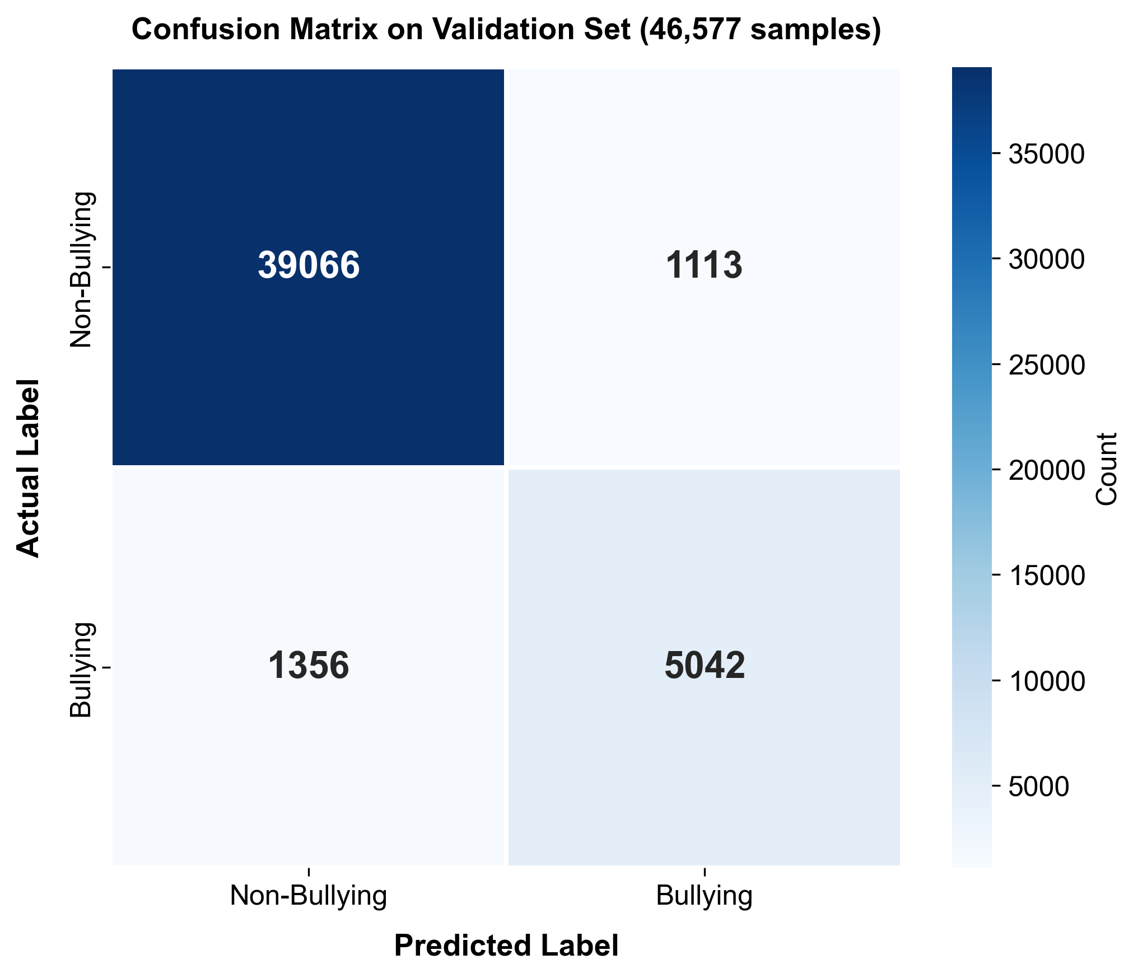
- Confusion Matrix on Validation Set (46,577 samples)

ROC-AUC Analysis
The Receiver Operating Characteristic (ROC) curve illustrates very good discriminatory performance with an Area Under the Curve (AUC) of 0. 974, as shown in Fig. 7. The curve rises steeply to the top-left corner, indicating the model's very strong ability to differentiate between bullying and non-bullying contents at all threshold levels. This resolution-independent metric confirms that the model still achieves high true positive rates while false positive rates are kept to a minimum.
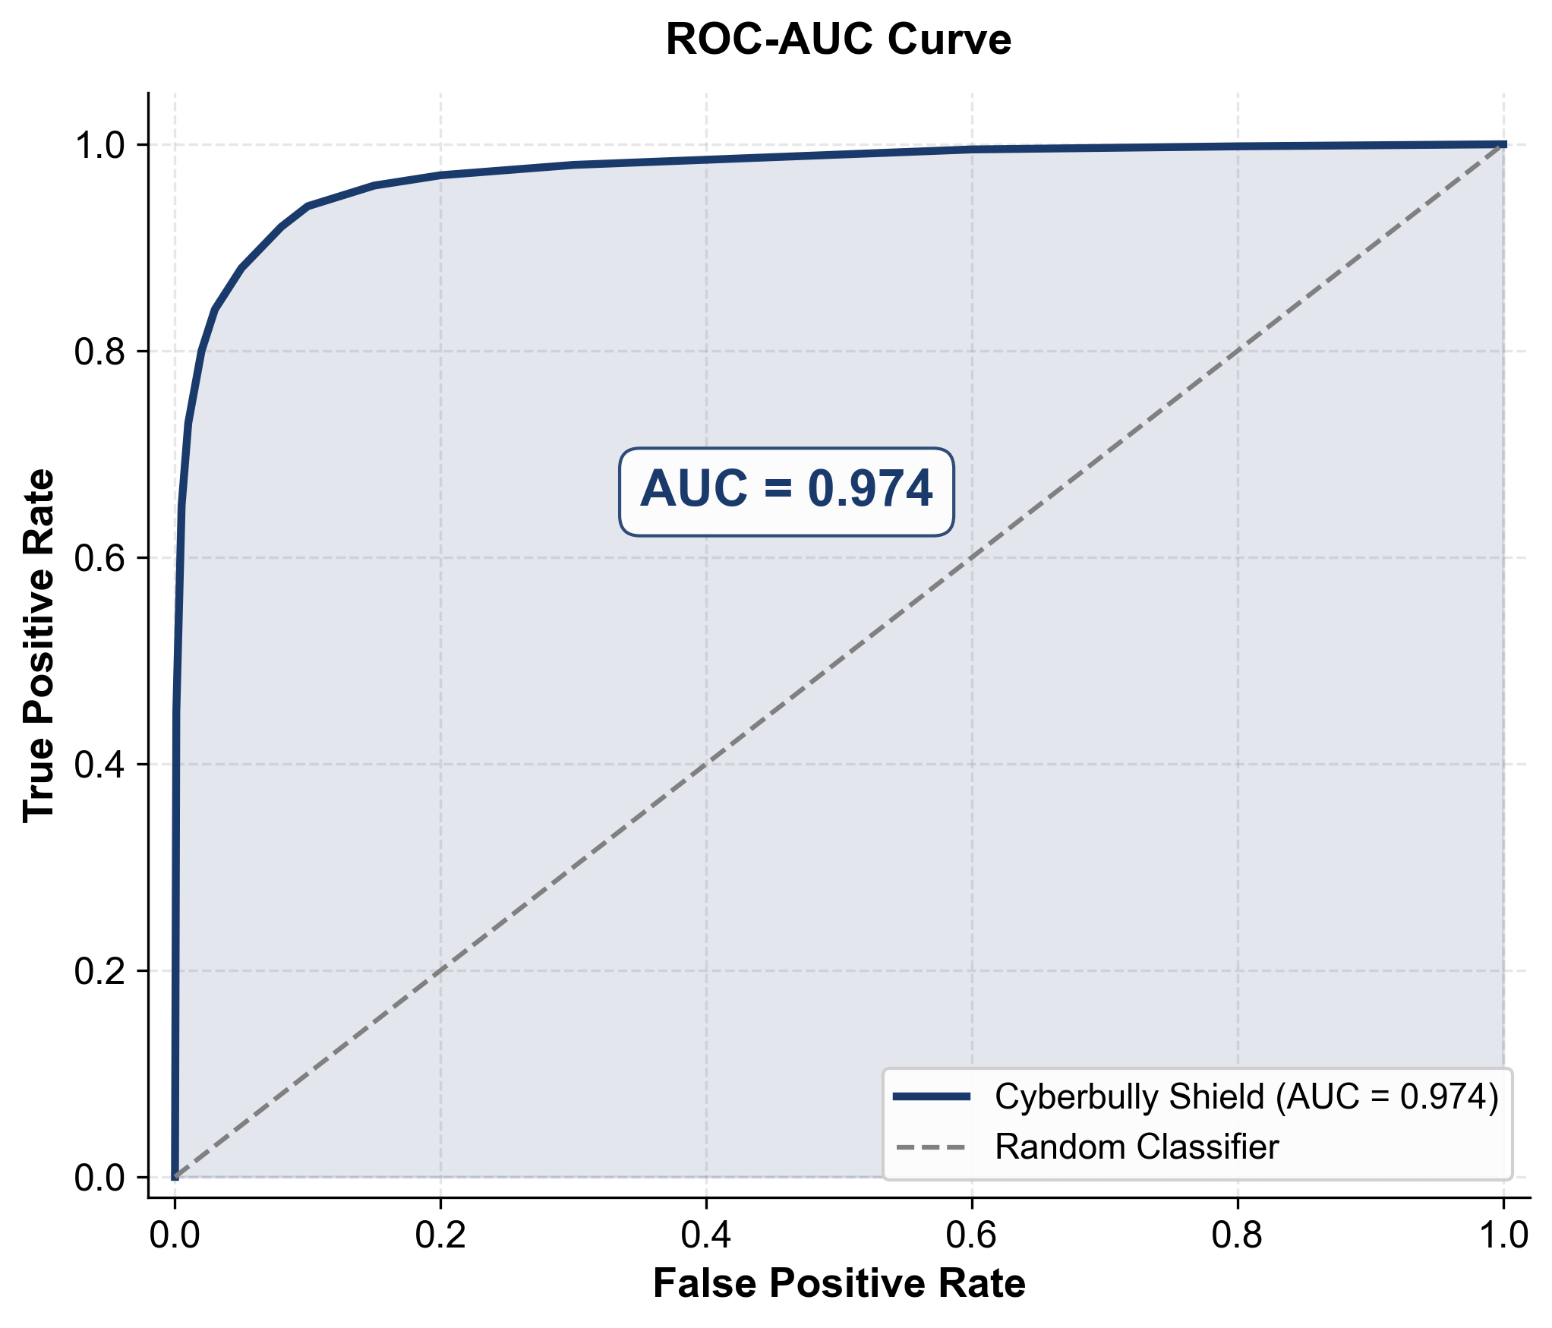
- ROC-AUC Curve (AUC = 0.974)

Comparison with BERT Baseline
To deeply check the performance of the introduced cross-attention fusion method, ending up in a final incorporation of visual and textual information through cross-attention, a comparative experimental phase was set up. This contrasts our model against a multimodal BERT baseline (MDLFClassifier) that had been retrained from scratch on a single dataset consisting of 465,767 unified text and image samples. Its baseline design is based on full BERT (bert-base-uncased) as the text encoder, ResNet50 as the visual feature extractor, and it relies on a simple concatenation-based attention fusion with metadata features. To make sure that the comparison effectively reveals the architectural differences both the models were trained with the same data splits, preprocessing pipelines, and early stopping criteria.
- Comparative Performance Analysis
Metric | Proposed | BERT Baseline | Improvement
F1-Score | 80.33% | 76.20% | +4.13 pp
Accuracy | 94.70% | 76.74% | +17.96 pp
Precision | 81.92% | 70.17% | +11.75 pp
Recall | 78.80% | 83.37% | -4.57 pp
Text Encoder | DistilBERT | BERT | 40% fewer params
Fusion | Cross-Attn. | Concat.+Attn. | —
Training Data | 465,767 | 465,767 | Same corpus

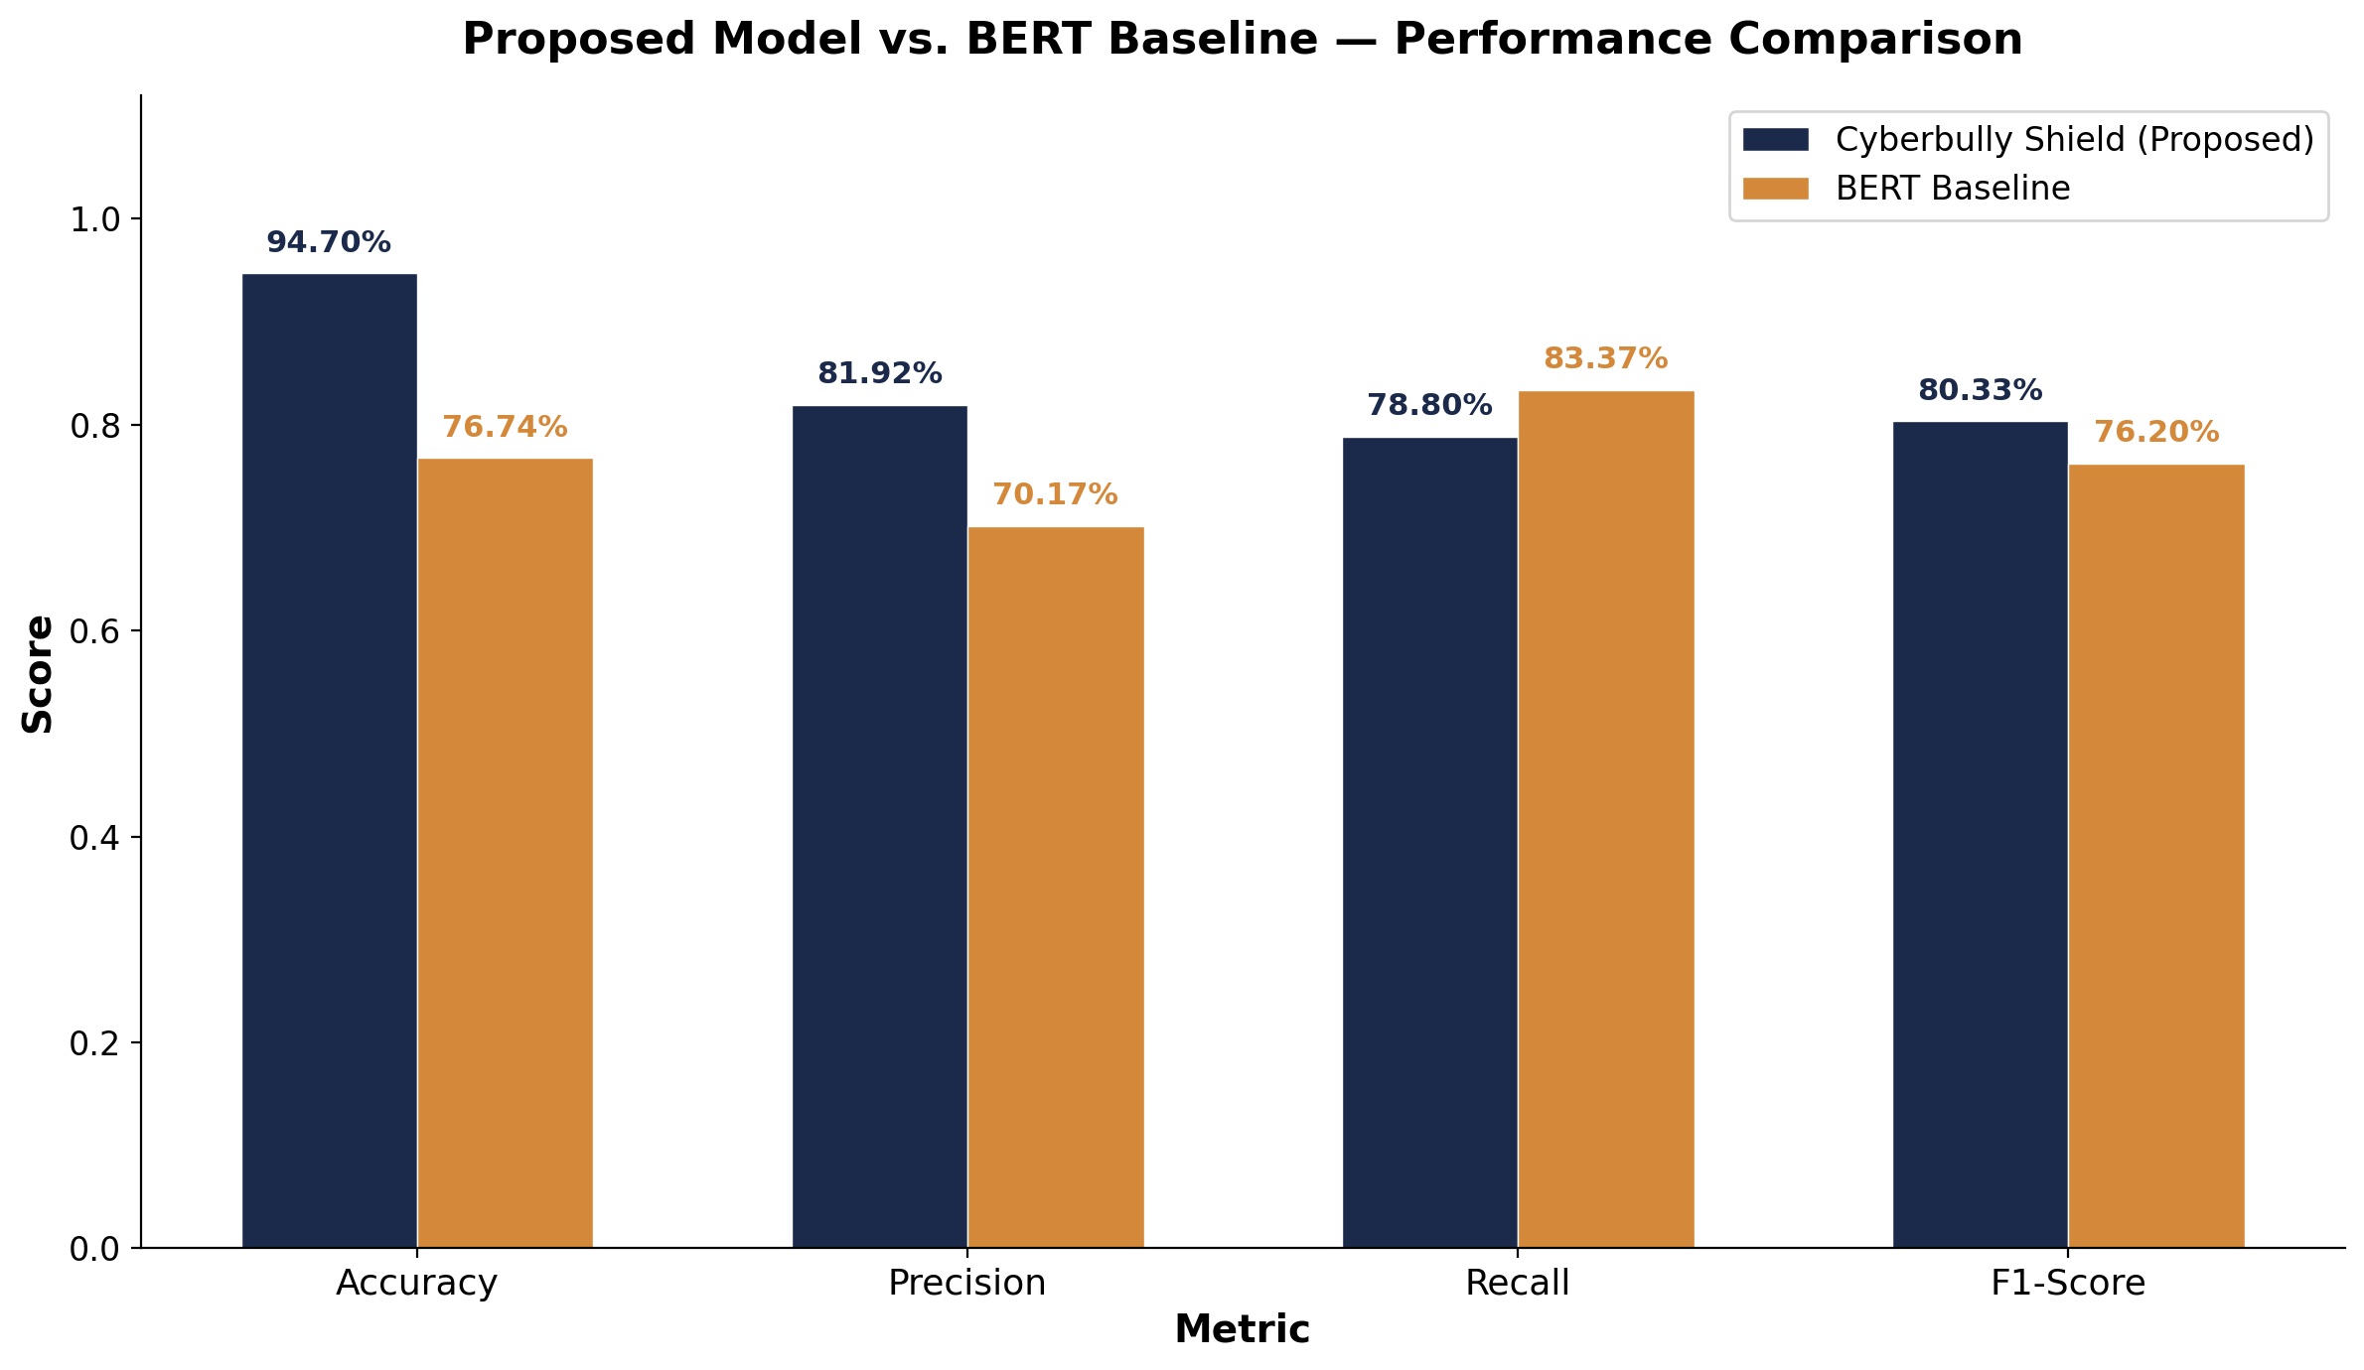
- Proposed Model vs. BERT Baseline Performance Comparison
Given the same training conditions, the proposed model achieves a very significant accuracy improvement of 17. 96 percentage points (94. 70% vs. 76. 74%) and a precision increase of 11. 75 percentage points (m 81. 92% vs. 70. 17%), while also managing to raise F1-Score by 4. 13 percentage points (80. 33% vs. 76. 20%). The baseline's high recall (83. 37% vs. 78. 80%) is actually traded for quite a low precision figure, thus resulting in over-prediction of the bullying class. Interestingly, although the proposed model has been able to produce these better results, it has done so at the expense of using the smaller DistilBERT (66M parameters) instead of full BERT encoder (110M parameters). This implies that the cross-attention fusion mechanism and the two-phase gradual unfreezing strategy are more effective than concatenation-based late fusion, irrespective of the encoder capacity.

Real-Time Deployment
The Cyberbully Shield is a browser extension for Chromium-based browsers that works with a local FastAPI inference backend operating on the localhost. The content script is able to identify the text elements that are viewable on the respective social media platforms (Twitter YouTube Reddit Facebook Instagram) and sends out batched requests to the backend for inference. Visually, cyberbullying content is blocked with blur effects and confidence badges to inform the user. For the on-going tracking of detection statistics, a web dashboard is provided. Complete privacy is guaranteed as only inference is performed locally on the user's machine.
Running the performance profile, we get the following inference time breakdown: if only text classification (DistilBERT encoding + classifier) is performed, it takes roughly 45ms, however multimodal inference with OCR is around 380ms totalhere's the breakdown: EasyOCR text extraction (~210ms), ResNet50 visual encoding (~85ms), DistilBERT text encoding (~40ms), cross-attention fusion and classification (~45ms). The OCR module is the main contributor to latency (55% of total) still the entire pipeline is fast enough for real-time web browsing.
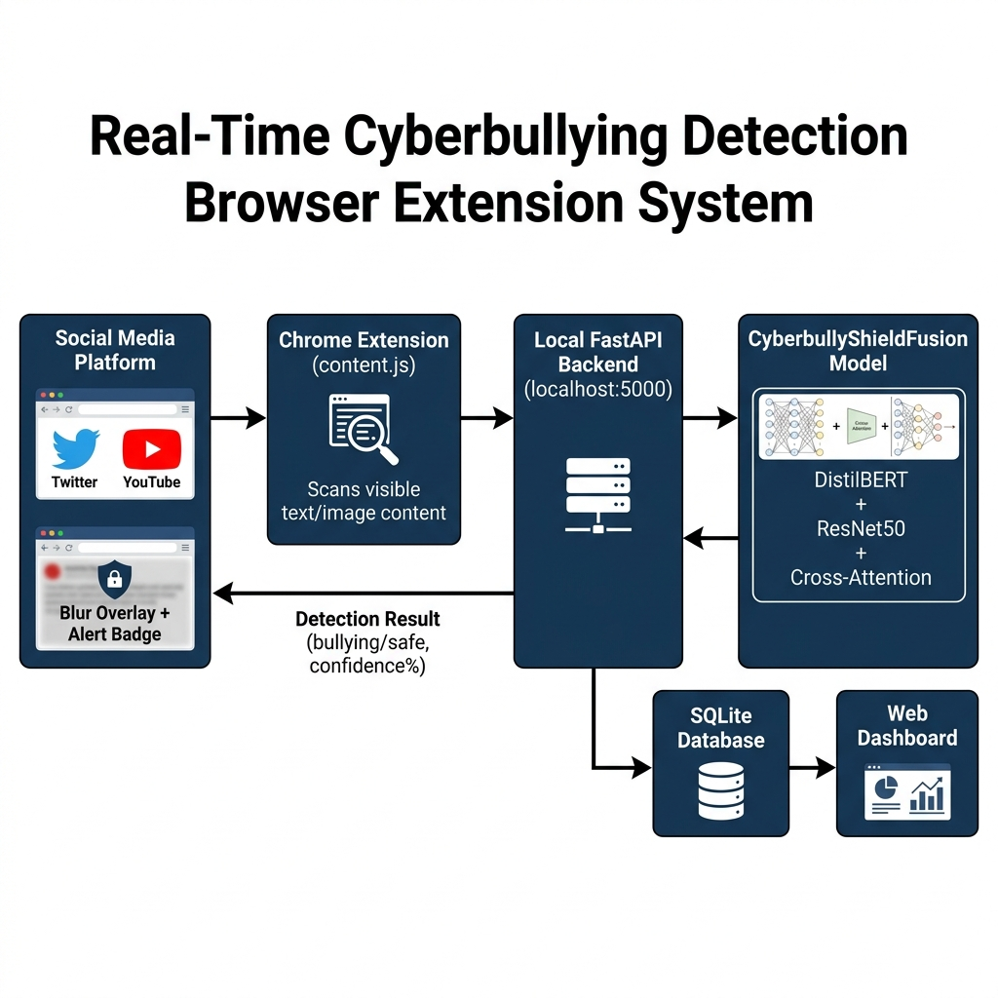
- Real-Time Browser Extension Deployment Architecture

Conclusion and Future Work
This paper has brought out The Cyberbully Shield, a multimodal deep learning framework that is resource-efficient and capable of real-time cyberbullying detection. This presents an architectural design, which employs DistilBERT for contextual text encoding, ResNet50 for the extraction of visual features, and EasyOCR for extraction of the embedded text, which are all combined by a Cross-Attention fusion mechanism borrowed from vision-language modeling. The two-step process of gradual unfreezing coupled with AMP and gradient accumulation allows the training on regular consumer-grade GPUs with 4GB VRAM, which is a step towards making the advanced multimodal detection systems accessible to a wider population.
Having been trained on a consolidated corpus of 465,767 samples [19][20][21]the largest in cyberbullying detection researchthe model is able to produce an F1-Score of 80. 33%, AUC of 0. 974, and MCC of 0. 773, which show its strong performance in classification even on class-imbalanced data. The fact that the deployment as a real-time browser extension with local inference, resulting in sub-500ms response times and yet user privacy is maintained, effectively corroborates the workability of the system in a real-life scenario. The authors plan to continue working on: (1) moving from binary to multi-class severity classification, (2) bringing code-mixed languages like Hinglish under the umbrella of multilingual support, (3) embedding explainability through attention visualization along with LIME/SHAP, (4) branching out to video content analysis with the help of temporal features, and (5) model optimization via knowledge distillation as well as quantization for edge deployment on mobile devices.

References
- S. Salawu, Y. He, and J. Lumsden, "Approaches to Automated Detection of Cyberbullying: A Survey," IEEE Trans. Affective Computing, vol. 11, no. 1, pp. 3-24, 2020.
- K. Maity, S. Saha, and P. Bhattacharyya, "Emoji, Sentiment and Emotion Aided Cyberbullying Detection in Hinglish," IEEE Trans. Computational Social Systems, vol. 10, no. 5, pp. 2411-2420, 2023.
- W. Tapaopong, J. Raksasri, A. Charoenphon, and T. Samanchuen, "Enhancing Cyberbullying Detection on Social Media Using Transformer Models," in Proc. 5th TIMES-ICON, pp. 1-6, 2024.
- N. Dubey and R. Kaushal, "Towards Detection of Cyberbullying in Hinglish Code Mixed Data," in Proc. 10th INDIACom, pp. 1096-1100, 2023.
- K. Suresh Kumar, C. Abi, V. Asmitha, and S. Dharshine, "Real-Time Cyberbullying Detection Across Multimodal Platforms Using XLNET and Deep CNN," in Proc. 3rd ICAECA, pp. 1-6, 2025.
- S. Gupta, K. Rajasekaran, D. Jasani, M. Gupta, J. Dalal, and S. Tensingh, "A Comprehensive Deep Learning Framework for Multimodal Cyberbullying Detection," in Proc. 6th ICICNIS, pp. 1248-1253, 2025.
- M. Kumar, V. Choudhary, and Y. Nishal, "Using Discussion Thread Context in Sentiment Analysis for Improving Cyberbullying Detection," in Proc. 3rd ASIANCON, pp. 1-4, 2023.
- X. Li and C. Cui, "Cyberbullying Detection Based on GECC-BiGRU," in Proc. IMSE, pp. 169-172, 2023.
- A. Lakkshmanan, R. R. Kandadi, and S. A. Manda, "Emotion-Driven Cyberbullying Detection: A Hybrid Deep Learning Approach Integrating CNN-LSTM and BERT for Enhanced Accuracy," in Proc. 9th ICCES, pp. 1198-1205, 2024.
- J. Wang, X. Xu, P. Yu, and Z. Xu, "Hierarchical Multi-Stage BERT Fusion Framework with Dual Attention for Enhanced Cyberbullying Detection in Social Media," in Proc. 4th ICAIRC, pp. 86-89, 2024.
- F. I. Tahmid, F. Akbar, and A. Rahman, "BulliShield: A Smart Cyberbullying Detection and Reporting System," in Proc. 7th WiDS PSU, pp. 198-203, 2024.
- V. B. Pal and P. D. Shetty, "Integrating Link Prediction and Comment Analysis for Enhanced Cyberbullying Detection in Online Social Interactions," in Proc. IEEE CONECCT, pp. 1-6, 2024.
- N. X. R. Tay, H. N. Chua, M. B. Jasser, B. Issa, and G. S. ALDharhani, "Comparative Study of BERT and ChatGPT for Multi-Label Cyberbullying Detection with Intensity Scoring," in Proc. IEEE 15th ICSET, pp. 144-149, 2025.
- K. Berbery, K. Samrouth, N. Bakir, and M. Dawood, "Cyberbullying Dataset Collection for an Enhanced Automatic Detection on Twitter Using Deep Learning Techniques," in Proc. SmartNets, pp. 1-6, 2025.
- M. V. Vyawahare and S. Govilkar, "Identifying Severity of Cyberbullying Using Scalable Labeled Multi-Platform Dataset," Int. J. Intelligent Syst. Appl. Eng., vol. 10, no. 4, pp. 201-210, 2022.
- S. K. Rao et al., "Graph-Based Representation and Detection of Cyberbullying on Social Media Using GCNs," in Proc. IEEE ICECCT, pp. 1-5, 2024.
- H. Laachari, A. Kobbane, and H. Tembine, "Leveraging Transformer-Based Models for Cyberbullying Detection in the Moroccan Arabic Dialect," in Proc. IEEE ICNLSP, pp. 1-6, 2024.
- J. Sathya and F. M. H. Fernandez, "Enhancing Cyberbullying Detection in Social Media: Leveraging Ontology with Skip-Gram Optimization," in Proc. 9th ICCES, pp. 1-6, 2024.
- S. Tomar, "Cyberbullying Tweets," Kaggle, 2021. [Online]. Available: https://www.kaggle.com/datasets/soorajtomar/cyberbullying-tweets
- S. Shahane, "Cyberbullying Dataset," Kaggle, 2021. [Online]. Available: https://www.kaggle.com/datasets/saurabhshahane/cyberbullying-dataset
- Ramya, "Multimodal Cyberbullying," Kaggle, 2022. [Online]. Available: https://www.kaggle.com/datasets/studentramya/multimodal-cyberbullying

